| **Aspect** | **E-Business** | **E-Commerce** |
| --- | --- | --- |
| Definition | E-business (electronic business) refers to the use of digital technologies and the internet to conduct various business processes, which can include marketing, sales, customer service, supply chain management, and more. | E-commerce (electronic commerce) specifically involves buying and selling products or services online, typically between businesses and consumers or between businesses. |
| Scope | Broader in scope, encompassing a wide range of online business activities, such as online marketing, customer relationship management, electronic procurement, online collaboration, and more. | Focused on online transactions involving the buying and selling of goods and services. |
| Nature of Transactions | Can include non-commercial interactions, such as customer support, online marketing, knowledge sharing, and collaboration among businesses and with customers. | Primarily commercial in nature, with the central objective of facilitating online transactions, which may include business-to-consumer (B2C), business-to-business (B2B), or consumer-to-consumer (C2C) transactions. |
| Goals and Objectives | Often aims to enhance overall business efficiency, improve customer experiences, and enable digital transformation across various business functions. | Main goal is to facilitate and optimize online sales processes, increase revenue, and expand market reach. |
| Examples | - Implementing a customer relationship management (CRM) system to manage customer interactions. - Using online collaboration tools to work with remote teams. - Conducting market research and marketing campaigns online. | - Setting up an online store to sell products directly to consumers. - Enabling electronic procurement to streamline B2B purchasing processes. - Participating in online auctions or marketplaces. |

E-commerce types:

B2B,b2c,c2c,b2e,egovernment,g2c,g2b,mcommerce

Ecommerce mechanisms

* Electronic catalogs
* Electronic auctions
* Electronic storefronts
* E malls
* Electronic marketplaces

Electronic payment methods

* Electronic cheques
* Electronic cards
* Virtual Credit cards
* Purchasing cards
* Stored value money cards
* Smart cards
* P2P payments

Three types of public exchanges

* Vertical
* Horizontal
* Functional

Benefits of SC

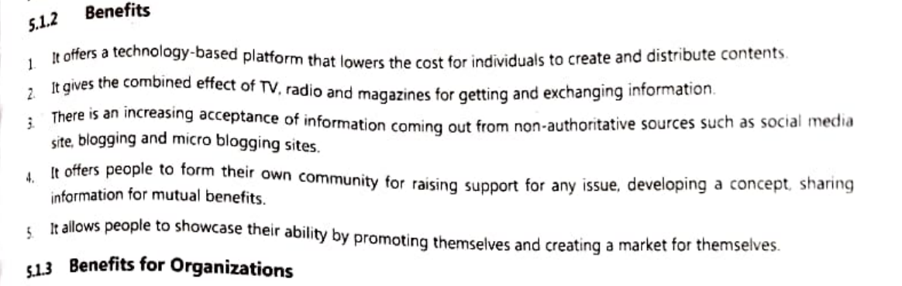

1. Increased collaboration
2. Enhanced innovation
3. Better productivity
4. Better employee relations
5. Better promotion and public relations
6. Inspired customer services



SC in Shopping

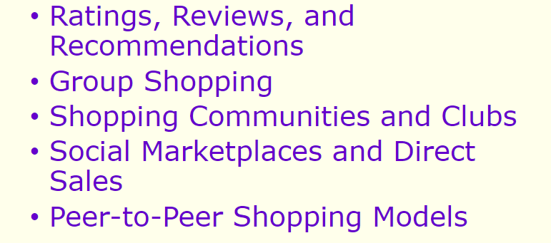

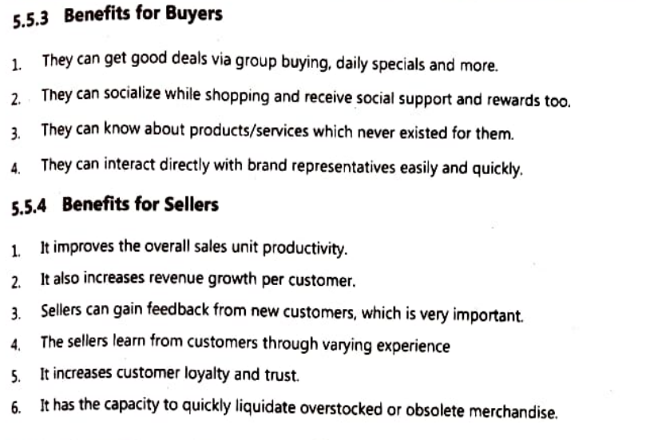

Pg 76